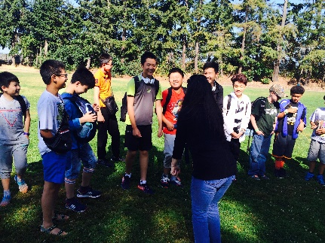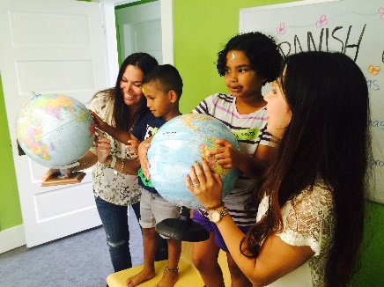
Washington Elementary
Days: Fridays
Start Date: October 6th, 2017
Time: 3:35pm – 4:15pm
Number of Classes: 25
Cost: $289.00 p/child
Deadline: September 30th, 2017
Register online at
www.chi-chack.org

Additional Info:
- Minimum of 7 students needed to hold a class, maximum of 15.
- Payments are processed once the class reaches the minimum number.
- Website: www.chi-chack.org

Chi-Chack Community Language Center, a Tacoma based non-profit, is offering a language enrichment program to the students at your school! Our Spanish classes are lively, interactive, and boost student's confidence in learning another language. Our teachers follow a specialized curriculum and are passionate about sharing their language and culture with our students!

Program Coordinator: Administrative Specialist: Parent Coordinator:
Yorleny Clapper Emily Bayer Kellie McGivney
(512) 225-4777 (253) 507-7510 206-769-1309
yorleny@chi-chack.org classes@chi-chack.org kelliem.73@gmail.com

