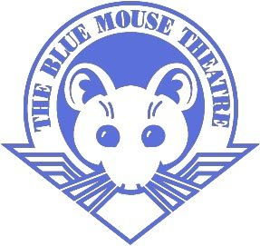
September 30th

Zootopia
Doors open at 3:45, movie will start at 4:00
Join us for our first movie night of the year at the Blue Mouse Theatre!
$5 per ticket, concessions will be available
Students/children must be accompanied by an adult.
Contact Jennifer Ruggles with questions @
253-961-9643 or jennruggles@gmail.com

……………………………........................................................
Return your ticket order to the school office by September 23rd
Tickets $5 _____ Student Name__________________________
Cash____ Check____ Teacher____________________ _________
Email____________________________
(Tickets will be sold until we reach Max capacity of the theater)

